**Section 2.1: Brainstorming – Ideation Phase**

**Overview**

The brainstorming phase for the Public Transport (RTC) Management System marked the foundation of the entire project lifecycle. It aimed to systematically identify key operational challenges and explore how Salesforce CRM could be used to address them effectively. The central idea was to replace legacy systems and manual processes with a cloud-based, automated, and real-time platform tailored to the needs of transport operations.

As Salesforce offers a highly customizable environment with robust tools for data management, automation, and visualization, the project stakeholders aligned on leveraging it to digitize all aspects of RTC operations—from driver shift allocations to fare tracking and daily performance dashboards. This phase not only involved technical brainstorming but also business process alignment and expectation setting among stakeholders.

**Objectives of Brainstorming**

The main goals of the brainstorming phase included:

* Analyzing existing processes and identifying inefficiencies
* Exploring Salesforce-native solutions to public transport problems
* Defining stakeholder personas and their responsibilities
* Establishing core data entities and relationships
* Initiating design thinking to guide user-centered solutions
* Aligning organizational KPIs with potential Salesforce dashboard metrics

These objectives were mapped to the specific challenges faced by the RTC management system to ensure all pain points had a potential technical or process-level solution within Salesforce.

**Methodology**

A series of collaborative whiteboarding sessions, mind mapping, and feature mapping exercises were conducted with both technical and non-technical stakeholders. The sessions followed the Double Diamond approach — Discover, Define, Develop, and Deliver — to arrive at an effective Salesforce solution framework.

We used tools like Miro and Draw.io to capture mind maps and logic flows, while shared documents and in-person interviews with RTC officers helped capture operational nuances that were not evident from reports alone.

**Identified Stakeholders and Their Expectations**

| **Stakeholder** | **Role Description** | **Needs & Expectations** |
| --- | --- | --- |
| Drivers | Operate assigned bus routes | Clear shift timing, vehicle assignments |
| Conductors | Manage fare collection, passenger records | Reliable method for data entry, real-time sync |
| Station Managers | Schedule buses, assign roles | Live dashboard, shift calendar |
| Admin Officers | Oversee operations and compliance | Accurate data, scheduled reporting |
| Finance Officers | Monitor fare collection and daily revenue | Real-time fare dashboards, validation rules |

Each stakeholder group was analyzed using empathy tools and process simulations to map out their daily touchpoints with data. This helped us anticipate both their challenges and motivations for adopting the Salesforce solution.

**Problems Identified**

* Fragmented and siloed data sources across different RTC departments
* Repeated manual entries leading to duplication and errors
* Lack of automated validation and data consistency checks
* Time-consuming manual report generation processes
* No system-level accountability or workflow visibility
* Inefficient communication between bus depots and central command

These issues formed the foundation for our technical specifications and object model design in Salesforce.

**Key Ideas Developed During Brainstorming**

1. Establish a unified Salesforce Lightning App with modular objects for Bus, Employee, Trip, and Fare.
2. Use automation tools such as **Flows**, **Validation Rules**, and **Apex Triggers** to ensure data accuracy.
3. Develop **role-based dashboards** for real-time performance tracking.
4. Implement **lookup and master-detail relationships** to bind trips with buses, employees, and fares.
5. Integrate **shift scheduling** using calendar-style Lightning Pages.
6. Use formula fields for dynamic fare calculations.
7. Enable real-time passenger data reporting through mobile access.
8. Implement change tracking and audit trails for compliance.

**Brainstorming Visual Model**

**Diagram Title:** Brainstorming Concept Map – RTC Salesforce Application

* **Central Node**: RTC Management System
* **Branches**:
  + **Core Stakeholders**: Driver, Conductor, Admin, Finance
  + **Entities**: Bus, Station, Trip, Fare, Passenger
  + **Salesforce Tools**: Custom Objects, Flows, Reports, Apex
  + **UI Components**: Tabs, Record Pages, Lightning Pages
  + **Dashboards**: Trip Summary, Revenue Analytics, Shift Tracker

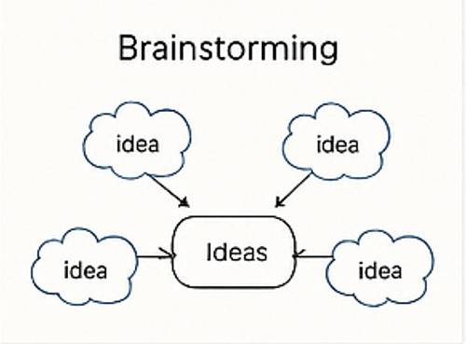

**Results of Brainstorming**

The brainstorming phase led to a solid foundational schema and clarified how Salesforce would be adapted to the RTC domain. Specific success criteria were defined, such as reducing reporting time by 50%, minimizing data entry errors, and enabling on-demand visibility of shift and fare data.

Additionally, it helped determine object relationships such as:

* **Trip ↔ Bus** (Lookup)
* **Trip ↔ Employee** (Driver, Conductor roles via multi-lookup)
* **Fare ↔ Route** (Master-detail for control over fare changes)

**Conclusion**

The brainstorming phase successfully generated a comprehensive understanding of the functional landscape of RTC operations. It enabled the identification of real pain points and mapped them to precise Salesforce tools and methodologies. The ideas generated during this phase served as the foundation for empathy mapping, requirement gathering, and ultimately, the development of a scalable and user-friendly CRM application for public transport management in Salesforce.

By taking a strategic and user-focused approach, this phase guaranteed that the application design would be robust, intuitive, and highly impactful across every layer of the RTC’s operations.